DUAL-DOMAIN STRUCTURED PRUNING
YOLO26n software progress, controlled recovery experiments, and publication plan
Current result: At approximately 10.25% parameter reduction, one 20-epoch fine-tuning session after pruning retained 98.45% of GEN and 94.72% of SNOW baseline mAP50–95. This is the strongest recovery result so far.

1. Purpose and current status
The study develops a physical, dependency-aware channel-pruning method for YOLO26n. General-domain performance (GEN) remains the primary requirement, while a snow-specific dataset (SNOW) is used to test whether pruning decisions transfer safely to a non-general domain. The final software model is intended for inference on the ARM processing system of a PYNQ-Z2.
Work completed: two research-grade baselines, a validated 51-group dependency catalogue, complete isolated sweeps at three pruning ratios, T1–T4 decision tables, and a controlled T5–T7 cumulative recovery comparison.
Work not yet proven: the final sensitivity/prunability equations, generalization across additional datasets and seeds, superiority over matched standard competitors, and measured PYNQ-Z2 feasibility.
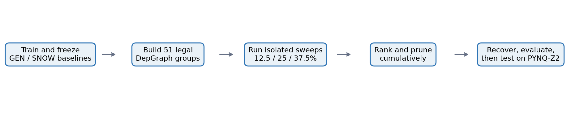
Figure 1. Overall software-to-hardware procedure
Description: The procedure follows the supervisor's original structure: separate GEN/SNOW baselines, legal dependency groups, isolated accuracy-drop tables, cumulative pruning and recovery, and final board testing.

2. Experimental basis
Table 1. Frozen baseline specification
Description: Both domains use independently trained YOLO26n models and a matched evaluation pipeline. The validation split guides pruning; the test split remains reserved.
Item | GEN | SNOW
Dataset | MIO-TCD localization | ACDC snow subset
Classes | 11 | 8
Image / batch | 640 × 640 / 16 | 640 × 640 / 16
Seed / optimizer | 42 / AdamW | 42 / AdamW
Maximum epochs | 100 | 100
Starting point | COCO-pretrained YOLO26n | COCO-pretrained YOLO26n
Primary metric | mAP50–95 | mAP50–95
Table 2. Baseline validation results
Description: These are the canonical full-precision validation baselines used to calculate accuracy drop. Mean Average Precision (mAP), floating-point operations (GFLOPs), precision, and recall are reported.
Domain | Parameters | GFLOPs | mAP50 | mAP75 | mAP50–95 | Precision | Recall
GEN | 2,508,090 | 5.7933 | 0.8310 | 0.7247 | 0.6471 | 0.7979 | 0.7795
SNOW | 2,506,920 | 5.7868 | 0.3263 | 0.1856 | 0.1920 | 0.5733 | 0.2531
The lower SNOW baseline is expected because the labeled snow training set is much smaller and less diverse. For this reason, raw accuracy drops are normalized to each domain's own baseline before joint comparison.

3. Literature lessons, research gaps, and uniqueness
Table 3. Literature findings and the gap addressed
Description: The reviewed papers supply established pruning components. The proposed work is positioned around their unresolved combination rather than claiming those components individually as new.
Paper | Relevant lesson | Gap targeted here
Li et al. (2017) | L1 filter importance, physical removal, sensitivity tests, recovery. | Single-domain classification; no matched adverse-weather detector analysis.
Fang et al. (2023) | DepGraph automatically traces structural pruning dependencies. | DepGraph itself is established; YOLO26n custom blocks and domain-aware decisions remain.
Jeon et al. (2023) | Resource constraints and safeguards against layer collapse. | No paired GEN/SNOW group-damage framework.
Lian et al. (2024) | Multi-rate sensitivity, cross-layer allocation, Batch Normalization recalibration. | Different allocation objective and no snow-focused YOLO26n study.
Wang et al. (2025) | Adverse-weather/domain sensitivity can guide detector pruning. | Domain-aware adverse pruning is prior art; the contribution must be narrower and experimentally specific.
The strongest defensible contribution direction is:
- A matched GEN/SNOW accuracy-drop benchmark over every legal YOLO26n dependency group and three channel ratios.
- A GEN-protected decision rule that uses SNOW as an additional case study without allowing GEN damage to be hidden.
- Custom legal pruning support for C3k2 and C2PSA dependency families, followed by DepGraph structural validation.
- Exact physical parameter and GFLOP changes, cumulative interaction checks, and controlled recovery schedules.
- A final software result tied to measured PYNQ-Z2 constraints.
Claim boundary: DepGraph and domain-sensitive pruning are not new by themselves. The custom YOLO26n support may be a useful implementation contribution, but a first-of-its-kind claim requires a fresh targeted search before submission.

4. Dependency-group construction
Pruning is performed on connected channel groups, not on isolated layer names. When an output channel is removed, matching channels in all dependent consumers and branches are edited so tensor dimensions remain legal.
Table 4. Validated dependency coverage
Description: The catalogue separates generic DepGraph groups, custom recent-YOLO block families, and fixed outputs that must not be pruned as ordinary feature channels.
Coverage item | Result | Meaning
Final pruning groups | 51 | Complete group catalogue used in the sweeps
Generic DepGraph groups | 42 | Directly generated and physically validated
Custom groups | 9 | C3k2/C2PSA families resolved with custom coupling
Convolution paths audited | 126 | Model-wide structural coverage check
Fixed prediction outputs | 12 | Intentionally excluded from ordinary pruning
Group-pair checks | 1,275 | Compatibility classifications recorded
No manual alteration was used to improve reported accuracy. Custom rules define which channels must be edited together; DepGraph and save/reload validation then verify that the resulting physical model is legal.

5. T1–T4 isolated pruning study
Every one of the 51 groups was pruned independently on GEN and SNOW at 12.5%, 25.0%, and 37.5% within-group channel ratios. This produced 306 domain evaluations. T1 and T2 contain the isolated accuracy drops; T3 contains dual-domain sensitivity; T4 contains the resource-aware ranking.
Table 5. Sweep completion and initial screening
Description: The eligible count uses the current experimental gate: normalized harm must not exceed 5% on either domain. Negative drops mean a small measured improvement, not automatically an error.
Within-group ratio | Groups evaluated | GEN negative AD | SNOW negative AD | Gate-eligible groups
12.5% | 51 | 0 | 4 | 21
25.0% | 51 | 0 | 4 | 16
37.5% | 51 | 0 | 2 | 11
The few negative SNOW accuracy drops are small isolated improvements. They should be repeated across seeds or evaluations before being interpreted as true regularization effects; they are clipped to zero only in the damage term so an apparent improvement does not create artificial negative risk.
The complete 51-row T1, T2, T3, and T4 tables for every ratio are retained in the accompanying CSV evidence. Only the completion summary and the most relevant 25% ranking are reproduced here to keep the report readable.

5.1 Current proposed scoring experiment
For domain d and pruning group i:
NAD[d,i] = (mAP[d,baseline] − mAP[d,pruned,i]) / mAP[d,baseline]
h[d,i] = max(0, NAD[d,i])
S[i] = max(h[GEN,i], (h[GEN,i] + h[SNOW,i]) / 2)
B[i] = 0.5 R[parameters,i] + 0.5 R[GFLOPs,i]
P[i] = sqrt(B[i]) / (1 + (S[i] / 0.05)²)
The screening gate requires h[GEN,i] ≤ 0.05 and h[SNOW,i] ≤ 0.05. This formulation protects GEN, includes additional SNOW damage, combines parameter and GFLOP benefit, and reduces domination by large parameter counts. It is a proposed experimental score, not yet the supervisor-approved final equation.
Table 6. Top 25% isolated prunability candidates
Description: These are the first ten groups in the current 25% T4 ranking. The ranking balances physical resource benefit against GEN-protected normalized sensitivity; it does not imply that all ten remain safe when combined.
Rank | Group | Parameters removed | GFLOPs removed | Sensitivity S | Prunability P
1 | DG025 | 36,896 | 0.02954 | 0.03327 | 0.06900
2 | DG026 | 16,512 | 0.01331 | 0.00083 | 0.06663
3 | DG004 | 16,512 | 0.01331 | 0.01708 | 0.05968
4 | DG040 | 18,464 | 0.01480 | 0.02968 | 0.05207
5 | DG019 | 4,624 | 0.01485 | 0.00853 | 0.04562
6 | DG034 | 4,624 | 0.01485 | 0.01664 | 0.04227
7 | DG008 | 4,624 | 0.01485 | 0.01725 | 0.04195
8 | DG009 | 4,624 | 0.01485 | 0.02141 | 0.03967
9 | DG014 | 1,160 | 0.01495 | 0.00604 | 0.03846
10 | DG035 | 4,624 | 0.01485 | 0.02581 | 0.03707

6. T5–T7 cumulative pruning and recovery
The 25% within-group ranking was applied cumulatively until approximately 10.25% of total parameters were removed. Twenty dependency groups were used. The strict cumulative gate plateaued near 7.57%; the final custom group was therefore a documented target-reaching override and must not be reported as a strict gate pass.
Table 7. Controlled T5–T7 recovery results
Description: T5 is the raw pruned model. T6 uses one 20-epoch session after all pruning. T7 uses five four-epoch recovery stages. T6 last is the fair full-budget comparison; T6 best is supplementary.
Domain | Run | Recovery | Params | Reduction | mAP50 | mAP75 | mAP50–95 | Retention
GEN | Baseline | None | 2,508,090 | 0.00% | 0.8310 | 0.7247 | 0.6471 | 100.00%
GEN | T5 | None | 2,250,986 | 10.25% | 0.3130 | 0.2319 | 0.1994 | 30.81%
GEN | T6 last | 20 at end | 2,250,986 | 10.25% | 0.8218 | 0.7139 | 0.6371 | 98.45%
GEN | T6 best | 20 at end | 2,250,986 | 10.25% | 0.8217 | 0.7159 | 0.6372 | 98.46%
GEN | T7 | 5 × 4 | 2,250,986 | 10.25% | 0.8112 | 0.6964 | 0.6234 | 96.34%
SNOW | Baseline | None | 2,506,920 | 0.00% | 0.3263 | 0.1856 | 0.1920 | 100.00%
SNOW | T5 | None | 2,249,816 | 10.26% | 0.1573 | 0.0850 | 0.0860 | 44.80%
SNOW | T6 last/best | 20 at end | 2,249,816 | 10.26% | 0.3258 | 0.1652 | 0.1818 | 94.72%
SNOW | T7 | 5 × 4 | 2,249,816 | 10.26% | 0.2932 | 0.1800 | 0.1671 | 87.02%
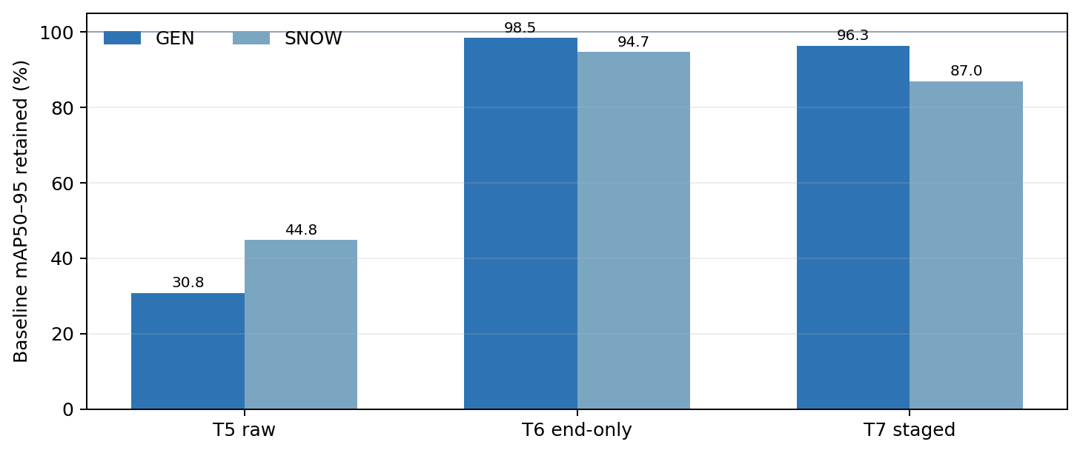
Figure 2. Accuracy retained after cumulative pruning
Description: End-only fine-tuning (T6) is strongest on both domains at the same 20-epoch budget. Raw pruning is highly damaging, while staged recovery remains effective but weaker with an equal four-epoch allocation.
Key findings:
- T6 exceeds T7 by 0.01370 mAP50–95 on GEN and 0.01479 on SNOW.
- After approximately 10.25% parameter reduction, T6 loses only 1.55% of GEN and 5.28% of SNOW baseline mAP50–95.
- Recovery is essential: T5 retains only 30.81% of GEN and 44.80% of SNOW baseline mAP50–95.
- A back-loaded staged schedule, such as 2+2+2+2+12 epochs, is justified as a future ablation but is not yet a result.
- T7 may recompute within-group channel importance from recovered weights; it is therefore not a perfectly pure schedule-only ablation.

7. Ho Yin comparison and role in the paper
Table 8. Relationship between the two pruning tracks
Description: The methods answer different questions. Whole-module experiments are useful diagnostic ablations; physical dependency-group channel pruning is the primary deployable compression track.
Aspect | Ho Yin layer-level work | My dependency-group work
Granularity | 23 top-level modules | 51 internal connected groups
Operation | Mask, zero, bypass, adapted bypass, or replace | Physically remove channels and dependent connections
Dense model size | Masking/zeroing may not reduce it | Physically reduced
Feature-flow risk | Coarse module removal or shape adaptation | Coupled dimensions preserved by DepGraph/custom rules
Best paper role | Ablation and competitor evidence | Primary structured-pruning method
The existing rankings show only partial agreement, which is reasonable because the granularity and operation differ. The supplied Ho Yin material should also be checked to confirm that the SNOW-trained baseline—not the GEN model—was used for the SNOW ranking before formal comparison.

8. Recommended next work
Table 9. Priority and ownership
Description: The order is designed to prevent unnecessary compression experiments before the actual PYNQ-Z2 requirement and the final decision equation are known.
Priority | Activity | Primary owner | Required output
1 | Run the unpruned baseline on PYNQ-Z2 ARM | Ho Yin | Load status, memory, model size, latency, throughput
2 | Freeze sensitivity, prunability, gate, and target | Rafed + Ho Yin + Ebrahim | Approved decision rule and hardware-informed reduction
3 | Run matched standard competitors | Ho Yin | Global L1, standard Torch-Pruning, random structured results
4 | Produce final cumulative pruned model | Rafed | Recovered GEN/SNOW models with exact resources and metrics
5 | Add datasets and repeat key seeds | Shared | Generalization and variability evidence
6 | Run final model on PYNQ-Z2 | Ho Yin | Measured feasibility and latency
7 | Freeze test protocol and run once | Shared | Untouched final test results

9. Publication readiness and risks
The current T6 result is promising enough to continue. It is not yet sufficient for a publication claim because the compression target is provisional and competitor, additional-dataset, seed, and board evidence are incomplete.
Highest technical risk: The parameter target may be too small or too large once PYNQ-Z2 memory and latency are measured.
Highest methodological risk: A score tuned to these two validation sets may not generalize without additional datasets and seeds.
Highest comparison risk: Different pruning methods can appear better if parameter reduction or recovery budgets are unmatched.
Highest claim risk: Calling established DepGraph or adverse-weather sensitivity novel would overstate the contribution.

10. Evidence locations
Table 10. Canonical evidence retained after cleanup
Description: These paths contain the final reproducible artifacts. Obsolete trials and redundant checkpoints were removed without deleting datasets, baselines, final models, or the complete isolated sweep records.
Evidence | Location
Project hand-off | PROJECT_CONTEXT.md
GEN baseline | results/baselines/b_gen_mio_yolo26n_s42_v1
SNOW baseline | results/baselines/b_snow_acdc_yolo26n_s42_v1
T1–T4 multi-ratio sweeps | results/pruning/prune_12_5, prune_25, prune_37_5
Cross-ratio master | results/pruning/MULTI_RATIO_PRUNABILITY_MASTER.csv
T5–T7 final comparison | experiments/recovery/recovery_10pct/FINAL_T5_T7_COMPARISON.csv
Final recovered models | experiments/recovery/recovery_10pct/T6 and T7/models/final
Ho Yin source material | external/HoYin
Literature evidence | literature/notes and literature/papers

References
Fang, G., Ma, X., Song, M., Mi, M. B., & Wang, X. (2023). DepGraph: Towards Any Structural Pruning. CVPR, 16091–16101.
Jeon, M., Kim, T., Lee, C., & Youn, C.-H. (2023). A Channel Pruning Optimization With Layer-Wise Sensitivity in a Single-Shot Manner Under Computational Constraints. IEEE Access, 11, 7043–7055.
Li, H., Kadav, A., Durdanovic, I., Samet, H., & Graf, H. P. (2017). Pruning Filters for Efficient ConvNets. ICLR.
Lian, Y., Peng, P., Jiang, K., & Xu, W. (2024). Cross-layer Importance Evaluation for Neural Network Pruning. Neural Networks, 179, 106496.
Wang, K., Fu, X., Lu, X., Ge, C., Cao, C., Zhai, W., & Zha, Z.-J. (2025). Efficient Test-time Adaptive Object Detection via Sensitivity-Guided Pruning. CVPR, 10577–10586.

ONE-PAGE SUMMARY
YOLO26n dual-domain dependency-aware structured pruning

Best result: T6 removes approximately 10.25% of parameters and retains 98.45% of GEN and 94.72% of SNOW baseline mAP50–95.
What has been completed
- Independent research-grade GEN (MIO-TCD) and SNOW (ACDC snow) YOLO26n baselines.
- A 51-group dependency catalogue: 42 generic DepGraph groups and 9 custom C3k2/C2PSA groups.
- Complete isolated GEN/SNOW sweeps for all groups at 12.5%, 25.0%, and 37.5% channel pruning.
- T1–T4 accuracy-drop, sensitivity, resource, and prunability evidence.
- A controlled 10.25% cumulative pruning comparison: raw T5, end-only T6, and staged T7.
Most important result
Table S1. Final controlled recovery comparison
Description: T6 last and T7 both use a total 20-epoch recovery budget. Baseline retention uses mAP50–95.
Domain | T5 raw | T6 end-only | T7 staged
GEN retention | 30.81% | 98.45% | 96.34%
SNOW retention | 44.80% | 94.72% | 87.02%
Interpretation: physical cumulative pruning initially damages both domains severely, but the damage is mostly recoverable. One continuous 20-epoch session at the end currently performs better than five equal four-epoch stages.
Proposed contribution
The publication direction is a matched GEN/SNOW dependency-group benchmark for YOLO26n, a GEN-protected dual-domain ranking, custom legal support for recent YOLO26n blocks, exact physical resource accounting, controlled recovery, and measured PYNQ-Z2 deployment evidence. DepGraph and domain-aware pruning must not be claimed as new individually.
Immediate decisions and actions
- Measure the baseline model on PYNQ-Z2 to set the real compression target.
- Freeze the sensitivity/prunability equations and accuracy gate with Ebrahim and Ho Yin.
- Run matched global L1, standard Torch-Pruning, and random structured competitors.
- Extend the evidence to additional GEN and SNOW/adverse datasets and repeat key seeds.
- Produce the final recovered model, then run the untouched test protocol and board evaluation.
Current conclusion
The project is on a credible publication track, and the T6 result justifies continuing. The method should not yet be called final or superior until the hardware target, competitor baselines, additional datasets, and repeatability checks are complete.

